software safety, software analysis, formal verification, metrics, logic model checking, distributed systems, multi-threaded software, static analysis, swarm testing, code review methods, requirements capture and analysis, algorithms, user interface design, graphic design, text processing, image processing, technology transfer.
 | history | before joining nimble research and jpl/caltech i worked in the cs research group at bell labs (1980-1981 and 1983-2003): a truly remarkable group that was given virtually complete freedom to pursue research goals, with no perceptible management oversight. i made a map of the 5th floor at stair 9 in building 2, the most desirable location for one's office at the time. the map lists the main occupants for each office over the years, with the person that occupied it the longest in red. from the 30-some people shown on this map, just a few remained to witness the final disappearance of center 1127 from the bell labs org charts in august 2005. most have found a safe haven elsewhere.

 | software tools | - cobra a generic, fast and light-weight, static and dynamic analyzer.  - spin efficient verification system for distributed software systems (a logic model checker).  - swarm pre-processor for spin, to setup swarm verification jobs on large numbers of cpus.  - scrub -- a peer code review support tool, used for safety- and mission-critical code. not yet available outside nasa.  - uno simple static analysis tool for ansi C programs, based on ctree 0.14. [see also this overview]  - ncsl.tar.gz line counter for C and C++ that reports the raw nr of lines, nr of non-comment and non-blank lines and the nr of comments.  - gh_cpp.tar.gz implementation of the C preprocessor, with some additional checking capabilities (can explain macro-expansions, and can check a small subset of the misra-c 2004 rules).  - older things (and mostly no longer kept up to date):  - feaver model extraction system for ansi C source code: the first step towards the development of a general purpose tool for the verification of distributed systems applications directly from program source text. the system was used at bell labs between 1998 and 2000 to exhaustively verify the call-processing software of lucent's pathstar access server. the source code is available, see also the modex distribution page.  - ubet requirements capture and analysis toolset from around 1995, originally called msc/poga, productized and supported within lucent as the ubet tool, but later abandoned when lucent more or less broke up.  - sdlvalid, an early verifier for sdl. the tool was written in 1987/1988, and was used internally for about five years. it was never approved for public release.  - microtrace a small demo awk-script for fsm verification, written 1987.  - pico/popi digital darkroom software (written 1984). here is also a tar archive pico.tar with the pre-ansi c source code that includes the little on-the-fly compiler that ken thompson and rob pike wrote (both now at google). the compiler in gen.c (from 1984) generated machine code for a vax. this code will of course not compile or run on any modern machine. see also pico's website.
 | books | - the spin model checker - primer and reference manual. describes the current version of spin, 608 pgs. addison-wesley publ., isbn 0-321-22862-6, september 2003.  - design and validation of computer protocols, prentice hall, 1991. the spin model checker was originally written for inclusion in this book in 1989. the book contains the full source text (about 5,000 lines) for the original version of spin.  - the early history of data networks, ieee computer society press (now wiley publ), 1995.  - beyond photography -- the digital darkroom, prentice hall, 1988. first book to coin the term digital darkroom; it predicted that the days of conventional photograph would be numbered, which has now come to fruition, though it took a little longer than we thought at the time. the book, with some background information, is accessible online via the link above.
 | papers | - publications, with pdf for most papers  - abstracts for selected papers
 | little movies | - pixelface, 1988, a five minute demo of pico/popi (mpeg 40mb).  a portion of the video was shown on cnn science & technology report in 1989: see clip.  - walkman, 1984, a 40 second try to make a little movie, with rob pike, don mitchell, and lillian schwartz (mpeg format, 7 mb).  a frame from the movie was used for the cover of ieee spectrum, june 1984.
 | logos | 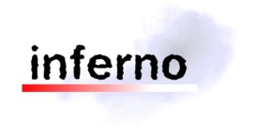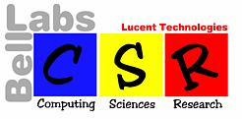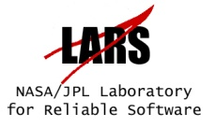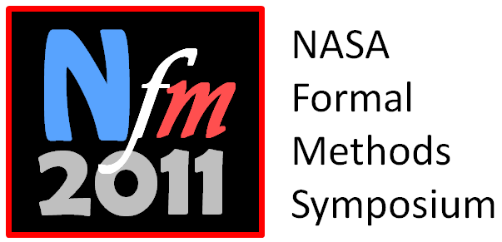  - the original inferno logo 1996  - cs research center logo (bell labs center 1127) 1997  - spin logo 2000  - nasa/jpl lars center logo 2004  - nfm2011 conference logo 2011
 | conference posters | 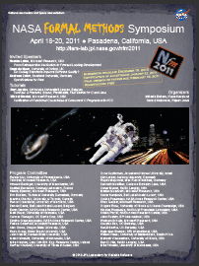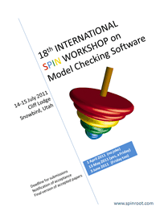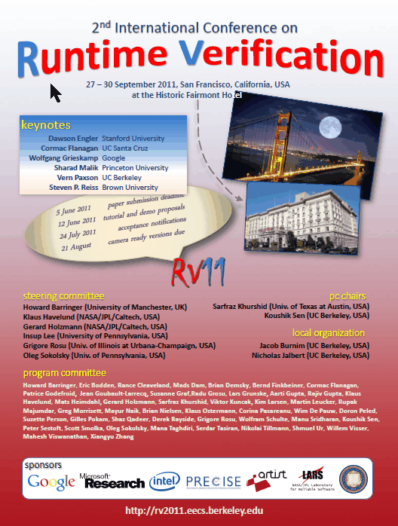  - 3rd nasa formal methods symposium, pasadena, ca, april 2011  - 18th spin workshop, cliff lodge, snow bird, utah, july 2011  - 2nd int. conf. on runtime verification, san francisco, ca, september 2011
 | cds | 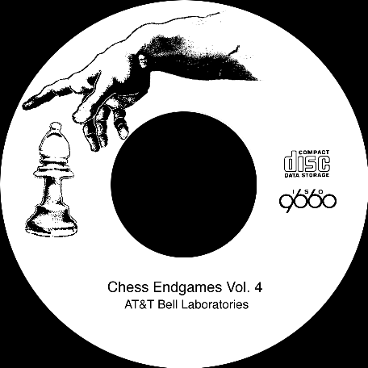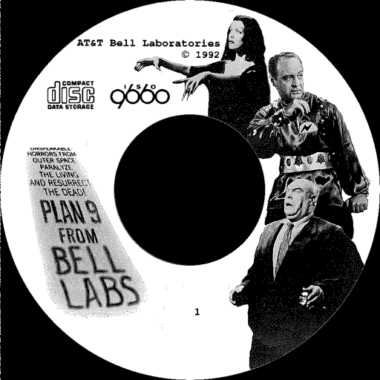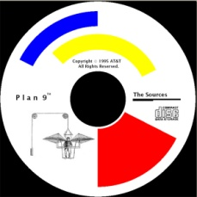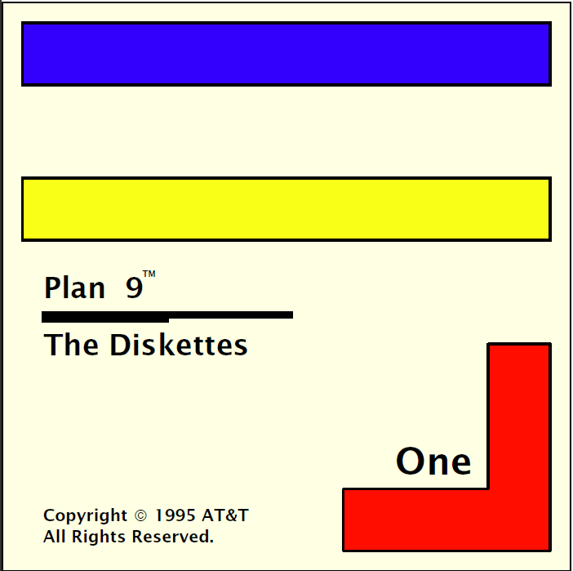  - cd, chess endgames, vols 1-4, (issued by ken thompson, 1991)  (chess-piece and a small part of leonardo da vinci's creation.)  - cd, plan-9 from bell labs, 1st edition, 1992.  (three actors from plan-9, the movie by ed wood)  - cds and cover for floppy disks, plan-9, 2nd edition, 1995
 | covers | 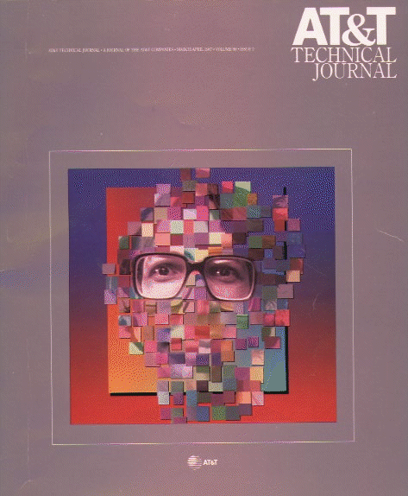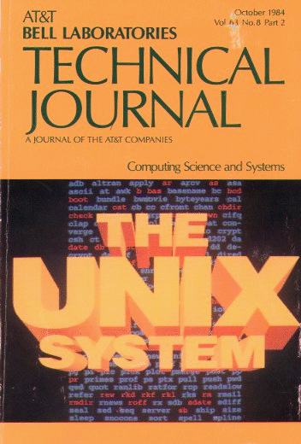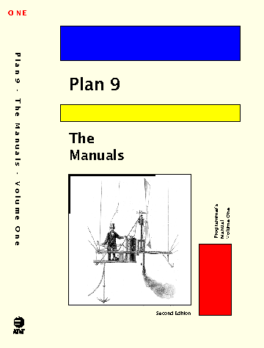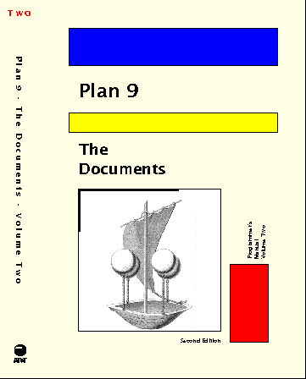  - at&t technical journal, march/april 1987, vol 66, issue 2.  (cover with a transformed pico/popi image of peter weinberger's portrait.)  - at&t bell laboratories technical journal, october 1984, vol 63, no. 8, part 2. special issue on unix (cover with computer generated graphics.)  - manual covers (2 volumes), plan-9, 2nd edition,  pub. harcourt brace & company, orlando, fl., 1995.  (illustrations from louis figuier, les merveilles de la science, paris 1867)
 | photos | - portraits, a small selection of the portraits i've taken in the last 25 years or so, mostly with a large studio view camera.  - masks and statues from the collection of norbert elias, taken between 1983 and 1987 in amsterdam. updated april 2014.  - pictures of tessa, the start of a well-documented life...
 | press | - Goodbye Bugs?, interviewed by Amy Castor for Bitcoin Magazine, Nov 22, 2017.  - 10 Dutch Superheros in IT, Nov. 2016 (in Dutch).  - ICT 2013 Vol. 18, 2013 (in Dutch).  - interview for The Setup...  - Gigaom, code review and analysis process followed for the Mars Science Laboratory Mission, 2012  - Caltech Engenious, interview on Safety Critical Software, 2011  - nasa tech briefs, who's who at nasa, 1 september 2009, interview with bruce bennett.  - software development times, 1 may 2009, interview with jeff feinman.  - cacm, july 2008, in search of dependable design, vol. 51, no. 7, pp. 14-16.  a couple of quotes from an interview with leah hoffman.  - story in ieee computer, jan. 2004  - interview with ftp online, oct. 2003  - interview with objectmonkey.com, oct. 2003  - MIT technology review, february 2003, brief mention in the category of software assurance, in article on ``10 emerging technologies that will change the world.''  - interview with software development magazine (SD magazine), on software verification, september 2002, p.15.  - NJN new nersey network news, an interview on software quality aired in the science and technology segment on march 6, 2002.  - two dutch journals, technisch weekblad, no. 17, and embedded systems, published interviews (in dutch).  - infoworld, october 26, 2001 short feature on code debugging.  - CIO magazine, august 1, 2001. brief mention of software verification project.  - new scientist, 18 november, 2000  - future of software column published in FTP magazine in 2000, fawcette publ.  - a series of columns on smart machines, published in Inc. technology
 | other | - ieee harlan d. mills award, may 2015  - nasa exceptional engineering achievement medal, october 2012  - acm fellow, june 2012  - caltech cs, faculty associate, may 2007  - jpl fellow, may 2007  - honorary doctorate, twente university, the netherlands, december 2006  - acm kanellakis theory and practice award, may 2006 (with vardi, wolper, and kurshan), pdf  - us national academy of engineering, elected member 2005. cs peer committee 2008-2011  - thomas alva edison patent award (with ken thompson and phil winterbottom), july 2003  - acm sigsoft outstanding research award, 2002  - acm system software award, 2001 (press release march 2002)

page last

